DAT 520 Problem Set Six

Michael Surdek

Southern New Hampshire University

1. **Assuming previous success [1 0], what is the probability of having a successful year?**

The probability of being successful after one year, given initial success, is 33%

1. **What is the probability of having two successful years?**

The probability of being successful after two years, given initial success, is 65.16%

1. **Using the strategy outlined in the document “How to Iterate Markov Processes in R,” show the table of values for 10 years of success:**

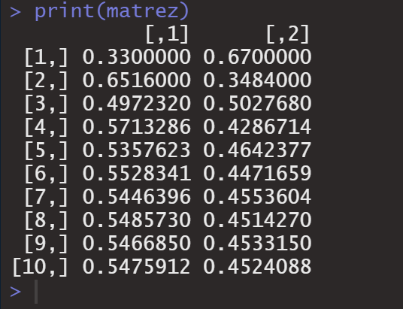

1. **Using the Success and 1-Success matrix output from problem 3, produce a line graph in Excel showing how the probabilities stabilize over time. It will look something like this:**

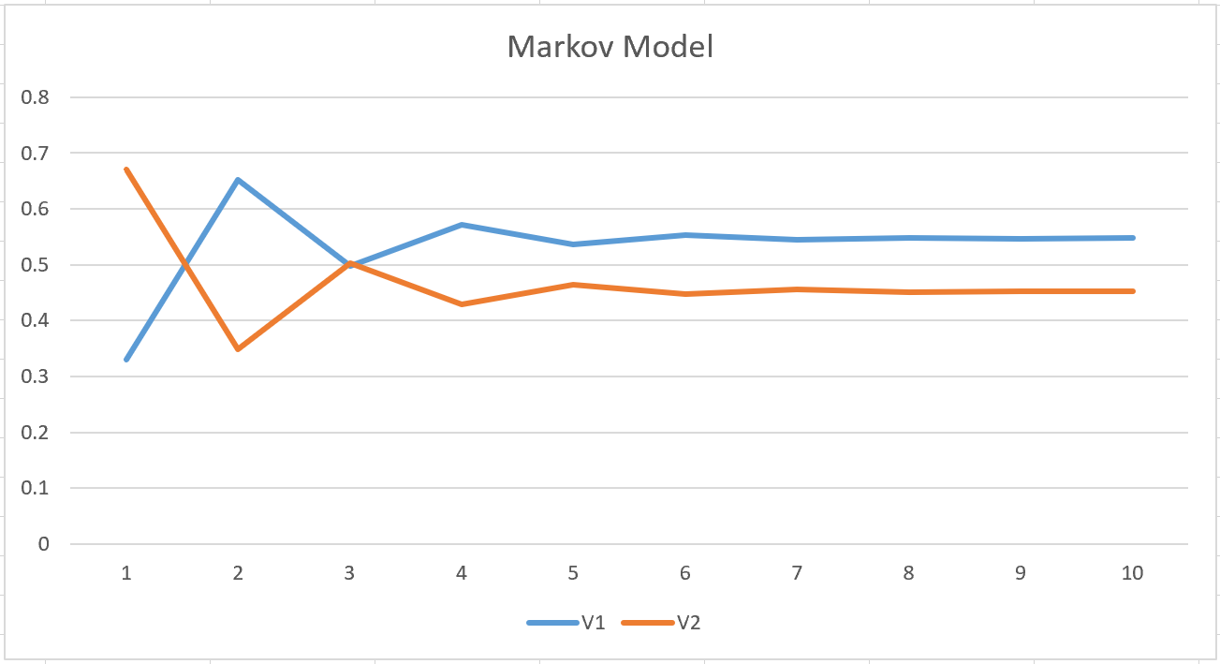

1. **At the end of 10 years, what are values of the blue and red lines? These are your new X% and 1-X% in the Tree Model. These represent the long-term probability of success or non-success, given the starting state of a business.**

After 10 years, given initial success, about 54.76% of businesses will be successful and about 45.24% will be unsuccessful. After year 10, approximately the same amount of businesses will change states between successful and unsuccessful, so these percentages will hold steady in years 11 and beyond.

1. **Should you employ Dustin to do the research or not? State the new EVs and explain your decision and what the tree is telling you. Use the new X% and 1-X% in your Problem 6 Tree model in Excel and recalculate the tree.**

It is better to employ Dustin to do the research. According to the decision tree, the expected value when employing Dustin to do the research is $33.14, whereas the expected value of no research is $25.80.

If no research is done, the tree says there is a 55% chance of a $252 profit and a 45% chance of a $248 loss.

If Dustin does the research, there is a 54% chance of it returning a negative result, in which case the decision would be to not buy and the only loss is the $16 invested in the research. On the other hand, if Dustin’s research returns a positive result, there becomes a 71% of a $236 profit and only a 29% of a $264 loss. The decision, tree aggregates these payoffs and likelihoods and it shows that there is a higher expected value when employing Dustin to do the research.

